Project on LALP (Language for Aggressive Loop Pipelining)
Karan Bhandari, Chris S. Tum, Chinmayi Kambhampati, Rogelio Cruz, Dwarkesh Prassana, and Prathima Sidda
Group 5, California State University, Long Beach, CA
Abstract- The world encompassing high performance computing has FPGA (Field Programmable Gate Arrays), ASICs (Application Specific Integrated Circuits) and GPUs (Graphical Processing Unit). In order to construct a high performance System-On-Chip we delve into FPGA and ASCIs. FPGA has garnered a lot of attention because they are programmable and reconfigurable. The world of computer engineering is split into hardware engineers and software engineers. Hardware engineers learn assembly, verilog or vhdl to program various embedded systems, but software engineers focus on the non-embedded gamut. Solution to most real world problems exists in software engineering because the domain is more mature due to easy programmability, lower learning curve, and faster return of investments. Expertise of hardware descriptive languages desires much attention and effort and moreover it takes more time to realize output. In order to combat that issue we needed to device a higher level programming language for the embedded hardware development. Attempts to develop such an approach have multiple issues due to the sequential nature of software and converting it into parallel instructions can be challenging. LALP, a language for aggressive loop pipelining has emerged to the forefront to redress the issues. It allows programmers to write high level code and use C like constructs; this is eventually converted to Hardware description language. This is done without sacrificing the parallelism that hardware offers, by enabling loop level pipelining. LALP allows the generation of hardware blocks and architectures. In this paper we are attempting to run and simulate most of the examples coined by the founders of LALP and also extend it by adding a thin GUI and web-services layer. We depict a few examples using graphviz, format inter-conversion and show a sample application using the web service, revamped GUI as well as the command line interface to achieve the inter-conversion. This report will also contain the results of simulation of max, Fibonacci and ADPCM. In the end we wrap up the paper by discussing about conceptual implementation of memory controller and UART (Universal Asynchronous receiver and transmitter). We were unable to demonstrate the “max”, “ADPCM” and “Fibonacci” examples on neither the NEXYS2 nor the Spartan 6 because the generated output is catered towards Virtex 5 which we did not possess. Nevertheless we developed the web service so that the LALP functionality can now be harnessed by any high level web mobile or desktop centric application environment.
The LALP was created so that software designers as well as FPGA designers could write inherently parallel FPGA by using aggressively pipelined setup on a higher level paradigm. The programmer has more controllers of clock cycles and hardware sections despite having a high level language construct. This allows programmers to write code as a quicker pace and provide an opportunity to implement popular algorithms like Dijkstra, DFS or bubble sort with minor modifications. Rather than advanced compiler techniques the LALP is depended on language qualifies and compiler directives.

- Syntax
LALP’s syntax has derived flavor from certain types, variables, expressions, loops and sync qualifiers from C. However certain differences that are apparent that its loops are implemented using counters and sync qualifiers which are specified by appending the “@” symbol followed by the number of clock cycles. With the advent of this syntax LALP avoids a data driven pattern. But it harnesses the counters to achieve maximum throughput by getting rid of a centralized controlling body like finite state machine (FSM). The conditional constructs can take paths in the loop of varying latency amounts, and still be optimized if each path that can be taken has its latencies represented by pipelining stages. Counter aids in implementation of the loop.
By surgically cutting into the code we can study the peculiarities of LALP’s syntax. An excerpt from ADPCM’s hardware block implementation is analogous to:
counter (length=0; length< SIZE; length++@10);
difference= value – precedingValue when len.step@3;
sign= difference < 0 ? 8: 0 when len.step@4

The “for loop” alters the value of “length” after 10 cycles. Followed by that statement, we specify that subtraction occurs in the third cycle of the loop.
One can define a macro by utilizing “[ ]”. For example
macro: <mem> [<index>] = <val> { mem.address = index; mem.data_in=val; }
This is constructed above the mem data structure which takes charge of address, data_out and data_in fields.
- Graphviz
It is the responsibility of the programmer to ensure that sync qualifiers are not incorrectly specified. While specifying the stage of pipelining via the “@” symbol. Incorrect sync qualifiers can result in out of order execution, overlapping instruction execution and possible deadlocks. The LALP compiler can output scheduling information as well as graphs that allow the programmer to expiate for specifying incorrect sync markers. Alternately it also allows the programmer to go berserk with pipelining by refining it further. Getting a right hit on the sync qualifiers is an art and it is done iteratively. The programmer needs to ensure that critical path latency is within the desired limit or reconsider all path options.
Apart from the software LALP allows us to inspect obtuse sharing of hardware units. Both data flow and control flow information is utilized to generate the graph.
Instruction scheduling also uses graph for guidance. Based on constrains specified in the graph we can wither use an ASAP (as soon as possible) strategy or an ALAP (as late as possible) strategy. In ASAP the proximity of the consumer and producer is diminutive whereas in ALAP the producers from the last nodes are drawn closer to the consumers. Synchronized scheduling can either be done by using delays or by using step signals.
Currently memory ports are supported by LALP apart from shift registers and multiplexers for input. The pressing drawback for LALP is insufficient or no support for floating point operations and they have support for a sparse gamut of hardware.
To illustrate the graphviz generation suite we depict the scheduling graph for dotprod (its purpose is to multiply the numbers and accumulate the output)

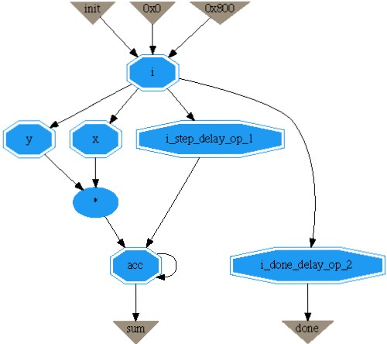
Fig. 1. Graphviz output for dotprod
This graph ensures that y and x is multiplied only after the next “i” for the loop iteration is available. The accumulation occurs only when the result of multiplication is available. This except of code defines the graph above
//definition of macro
const SIZE = 32;
const NUM = 32;
typedef fixed(SIZE, 1) int;
typedef fixed(1, 0) bit;
dotprod(out int sum, out bit done,in bit init) {
int x[NUM], y[NUM];int acc;
fixed(5, 0) i;
counter (i=0; i<NUM; i++);
i.clk_en = init;
acc += x[i] * y[i] when i.step@1;
sum = acc;
done = i.done@2;}

- Installing, setting and running LALP with inter-conversion
(The files pertaining to the project can be downloaded from the code.google.com repository within the LALP project)
  - Setting System parameters
- Install Java.
- Download lalp.jar
- Install the following libraries
  - JUNG (http://jung.sourceforge.net/)
  - Colt (http://acs.lbl.gov/software/colt/)
  - Commons Collections (http://commons.apache.org/collections/)
- Set JAVA_HOME variable to the folder containing java installation.
- Set LALP_HOME to the path containing the lalp.jar file.

  - Command Line Interface
Navigate to the folder containing lalp.jar
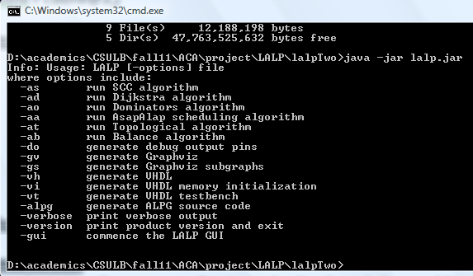
Fig. 2. Command line prompt LALP

When you type “java –jar lalp.jar”, it will depict multiple options. For example if you wish to inter-convert the file bubble_sort.alp to various formats we ought to follow the table scribed below.
Command | Expected inter-converted format
java –jar lalp.jar –vh bubble_sort.alp | Convert it to vhdl format
java –jar lalp.jar –vh –vt bubble_sort.alp | Vhdl testbench format
java –jar lalp.jar –vi bubble_sort.alp | Vhdl memory initialization
java –jar lalp.jar –gv bubble_sort.alp | Graphviz
java –jar lalp.jar –do bubble_sort.alp | Debug output pins
java –jar lalp.jar -ad max.alp | Run Dijkstra’s algorithm

- Graphical User Interface and Web Services
  - GUI
In order to invoke the GUI (Graphical User Interface) as well as the web services we ought to type
java –jar lalp.jar –gui

This will not only enable the GUI to perform the inter-conversion but also exposed SOAP based web services since the gui has a built in sun java httpd server.
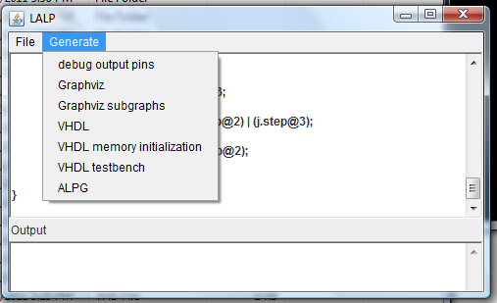
Fig. 3. Graphical UserInterface LALP

The GUI is a thin layer over the existing command line interface. We continue to use the Factory pattern offered by the original founders.

Once when the file is opened then the textbox is populated with the contents of the file. Whenever any call for inter-conversion is done then a temporary file is created. This temporary file is then used for inter-conversion to graphviz, vhdl or testbench generation.

A similar strategy is used for web services. But the only difference here is that the entire output is sent as a string to the client which has invoked the web method.

  - Web Services
In order to test whether the web service is functional or not we open the web browser and type the following url:

http://127.0.0.1:9877/webServices?wsdl

If you are able to see the XML format of exposed SOAP then the web service module is functional.

    - Use web services in perl
#!/usr/bin/perl -w
use SOAP::Lite;
my $url = 'http://127.0.0.1:9877/webServices?wsdl';
my $service = SOAP::Lite->service($url);
my $alpCode= #place alp code here
print "\nConverted ALP to VHDL: ", $service->vhdlGeneration($alpCode);

    - Use web service in java
Navigate to the directory where your java code files (ones that will use the web services) are located via command line interface.
Type

wsimport –keep http://127.0.0.1:9877/webServices?wsdl

This generates the service interface that your java application can utilize.

In your java code file import javax.xml.ws.Service and java.net.url
Create an instance of QName and another instance of service.
Extract the end point interface by “lalpServer endInterface=service.getPort(lalpServer.class)”
Use the end interface to access the lalpServer.

    - Sample Application in C# to harness the power of web services
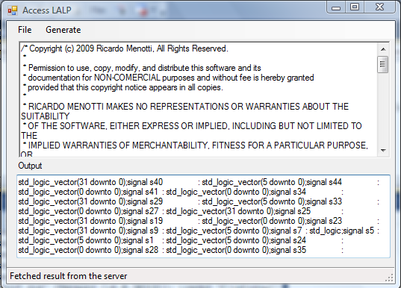
Fig. 4. C# application harnessing web services
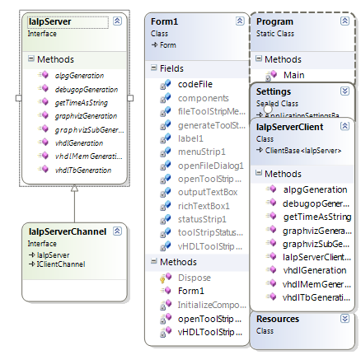
Fig 5. Class diagram of this application

- Architecture of LALP with the GUI and web services
  - Architecture

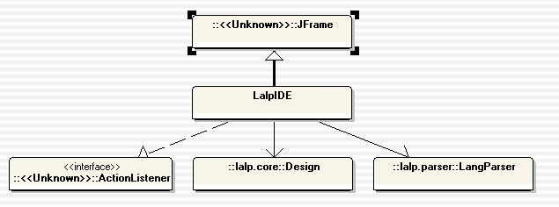
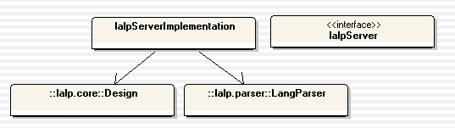
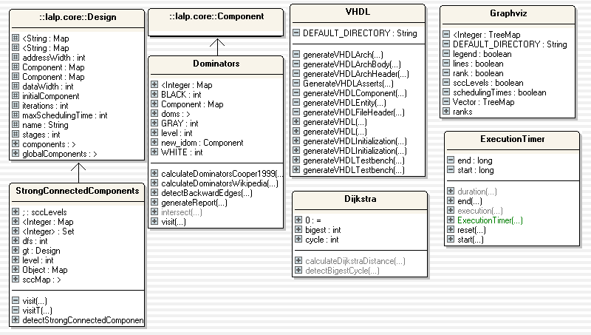
Fig. 6.a. Class diagram which elucidates the architecture of LALP

Fig. 6 illustrates the inheritance and association graph of the application. “LALP components” are crucial elements of the FPGA like counters, multiplexers, shift registers, arithmetic blocks, relational blocks and Boolean logic. VHDL.java is the class which is invoked when inter-conversion to vhdl or testbench is done. When a parameter is passed into the main or entry point the Factory pattern is utilized to guide the flow of the program. Suppose if the command argument is “–ad” then a new instance of Dijkstra’s class is created which executes the algorithm.

Graphviz owes its chunk of functionality to the JUNG library. JUNG is Java Universal Network/Graph Framework. It aids a developer to do analysis, and visualization of data. JUNG has a number of algorithms implemented within its arsenal from arenas like graph theory, social network and data mining.

Apart from the generic data structures that Java offers, LALP has reliance on the rich repository of data structures offered by Apache Common Collections. It provides advanced collections, iterators, maps, bags and high level type checking.

Advanced scientific computing, data analysis and scalability are offered by the Colt library.

LALP uses a technique called ALP. Aggressive Loop pipelining is an approach for pipelining loops in sequences of data. It uses high level languages for direct mapping loops into FPGAs. Unlike the previously mentioned approaches, ALP does not use software pipelining techniques. A fundamental difference is that there is no need to implement a finite state machine to control the ordering of instruction execution. Instead, the control is distributed over several operations. By using counters for controlling loops, it can efficiently pipeline even conditional loops.
ALP is claims to be bridge that unites higher level languages like C, with lower HDL languages. It does so by providing the powerful high level abstraction approaches that optimize code, while providing low level control of scheduling. ALP also provides deep pipelining analysis using font –end analysis tools. It comes equipped with several powerful loop control techniques built in such as a single centralized counter per loop, or distributed counters and control.
ALP is based on two main ideas that were developed for data-driven architectures:
- Dynamic Loop Pipelining
- Pipelining Sequence Loops of Data Dependent Loops
The Data-Driven approaches that these techniques were developed for do not directly apply to the scope of this paper.

5.2 Web Services
A web service allows your application to be distributed, thus enabling it to be deployed and executed on a plethora of devices. A web service could either be SOAP (Simple object access protocol) based or REST (Representational state transfer) based. In our project we use SOAP to expose the methods of LALP. SOAP is written in XML dialect for their message passing.

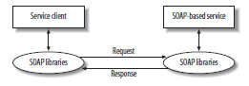
Fig. 6.a. Architecture of web services

This is analogous to a request/ response message passing pattern. Any language that is capable of processing SOAP headers can make a class to our web-methods exposed by the web service.

- Conceptual Memory Controller for NEXYS2
In order to interact with the on board memory it is crucial to have a memory controller on FPGA which is responsible for address encoding/decoding and data encoding/ decoding. It ought to have the capability to set and unset certain bits which are specific to board manufacturers. Conventionally the memory module on most board is implemented on VHDL this is further synthesized and processed to bit file. But here we use the aid of LALP, a high level language for writing highly parallelized FPGA logic using aggressive pipelining. LALP code for memory controller is provided. A sample implementation is presented, an implementation of memory controller on Digilent NEXYS2 in order for the processor (PICOBLAZE) to talk to the SDRAM manufactured by Micron.

MIB (Memory Interface Block) unit and external RAM interface in the fashion depicted in Fig 1.

MIB_unit
Processor
M
SDRAM

Fig. 7. Processor, MIB and multiplexer
The processor is the master that sends instructions and transmits/receives data that the SDRAM transmits to the processor through the memory controller. The reference processor that we take into consideration is PICOBLAZE. PICOBLAZE has capability to send and receive 8bits of data, but the SDRAM in our reference board has a 16bit bidirectional data pin. So the MIB and Multiplexer helps the processor to overcome the insufficient data bandwidth. The pin out of MIB is depicted in figure .
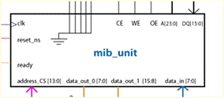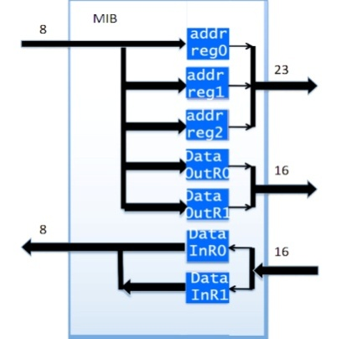
Fig. 8. MIB (Memory interface block) R: Address and data registers in MIB

Internally the core of the MIB is a state machine which is brandished by internal registers that is memory mapped to the processor via the decoder. There are three address registers which are loaded one by one before we commence a read or write operation. Figure 3 depicts how the address and data registers are connected. Figure 4 walks us through the various states of the memory interface block.
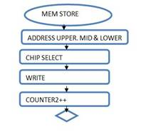
Fig. 9. a. Flowchart of memory write cycle
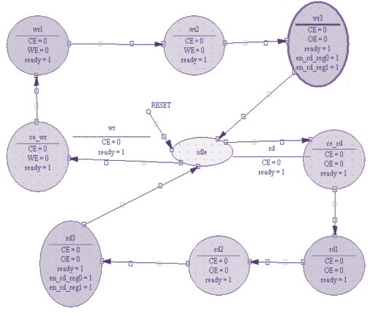

Fig. 9.b. The state diagram of MIB. Upper is write, lower is read

const DATA_WIDTH = 16;
const HALF_DATA_WIDTH = 8;
typedef fixed(DATA_WIDTH, 1) int;
typedef fixed(1, 0) bit;

MIB_unit(in clk,in rst,in wr,in rd,out bit ready,out bit CE,out bit OE,out bit WE,out bit enable_read,out bit enable_write)
{
int state_nxt;
int state_reg;
counter(i=0;state_nxt!=rst;i++@100);
state_reg=idle;
state_nxt=state_reg;
CE=0; when (state_reg==idle & wr==1) & i.step@2;
ready=1; when (state_reg==idle & wr==1) & i.step@3;
state_nxt=enable_write; when (state_reg==idle & wr==1) & i.step@4;
CE=0 when (state_reg==idle & rd==1) & i.step@2;

CE = 0 when (state_reg==enable_write & wr==1) & i.step@7;
WE = 0 when (state_reg==enable_write & wr==1) & i.step@8;
ready = 1 when (state_reg==enable_write & wr==1) & i.step@9;
state_next = wr1 when (state_reg==3 & wr==1) & i.step@10;

//similar for read
//process for state when write is between 3-5 and read is between 6-8
}

The conceptual state diagram and the LALP code is designed after carefully scrutinizing the Micron manual (source). Reason for spending 100ns in both the read and write cycle is explained in the manual. Since each clock cycle is 20ns we spend 4 cycles in read/write. And difference in size of data bus on either end has forced us to use six memory registers.

- Conceptual UART for NEXYS2
The universal Asynchronous receiver and transmitter (UART) is used to convert data from parallel to serial lines. It provides a basic interface to industry standard UART controllers, as well as an RS232 interface. It is comprise of a transmitter unit which loads data in parallel and shifts out in serial (one bit at a time) at a specific rate referred to as a baud rate. It also has a receiver that takes in data one bit at a time and assembles the entire data. The transmission starts with a start bit which in our case is a low signal or a zero, then it is followed by the data. There is a stop bit that signals the end of the data stream, followed by a parity bit, if used.

Our design was greatly influenced by the Actel CoreUART. It features support for baud rate up to 9600, 7 or 8 bits of data, parity (odd, even, or none), FIFO for both transmit and receive, buffered to maximize throughput, and support for RS232 as well as Industry Standard UART controllers. The major components that comprise our implementation are a baud rate generator, receiver, transmitter, and one word long interface (buffers) with FIFO for transmitter and receiver. Below we describe the receiving process in the UART, followed by the alp code.

The transmission begins with a start bit, which in our case is a low signal. The 7 or 8 data bits are sent right after that followed by the parity bit if you choose to use it. The parity bit is mainly used for error detection. If you choose even parity this bit is set to zero when the data bits have an even number of ones. For odd parity it is set to zero when you have an odd number of ones in the data stream. You then have a stop bit which varies from 1, 1.5 or 0 depending on the parity.

UART_rx ( in bit rx_en, in bit d_width, in bit parity,
in bit odd_or_even, out bit done, out int write_to_mem [ ])
{
bit clk_en;
const buff_length =9;
const SB_tick = 15;
Int data_in[ ];
int rx = 1;
int signal;
int s_tick;
int flag_nxt;
int rx_done_tick;
counter (len=0; len>= d_width; len++@30);
{
rx == 0; Diff = buff_length – len when len.step@1; //something to receive
signal ==01; when ( flag_nxt == idle & rx_buff == 1) & len.step@3;
s_tick==1; when (s!= 7) & len.step@5;s ++;//Start receiving
signal == 15; when rx == data_in[len] 7:1 & len.step@20;//receive 7 or 8 bit data
s_tick == 1; rx_done_tick = 0xff when len > 0?15:0 sb_tick;//Look for stop bit, end of message
data_in[len] = val;
write_to_mem[len] = val;//write to mem one bit at a time
Done = len.done;
}

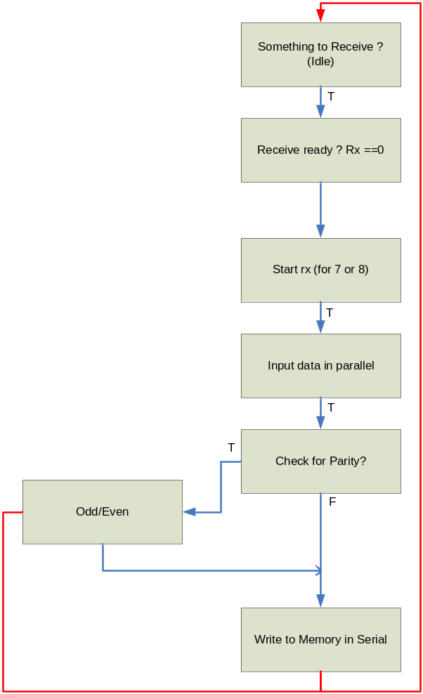
Fig. 10. UART

- Performance analysis

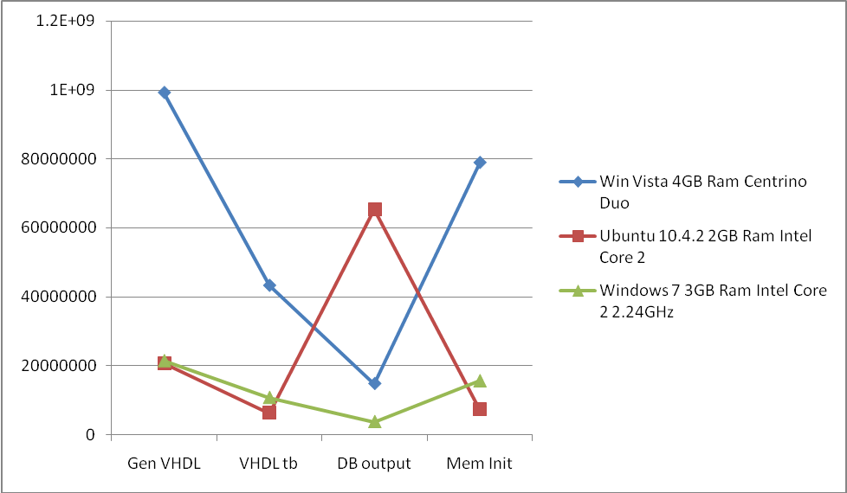
Fig 11.a. Performance analysis (time in nano seconds)

The Performance results are shown in the form of conversion time, the time taken to convert any .alp file to one of the .vhd file, Graphviz or even DB pin output.
We tested this on different operating systems including windows and linux (Ubuntu).
Fig 11.b depicts coverage analysis. Here we show the amount of time spent in each class during the inter-conversion and web service phase when the GUI is active. This indirectly implies the usage percentage of each code file.
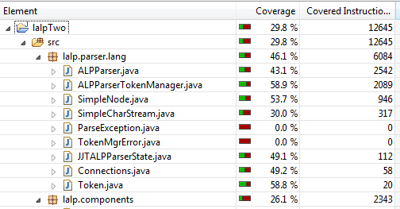
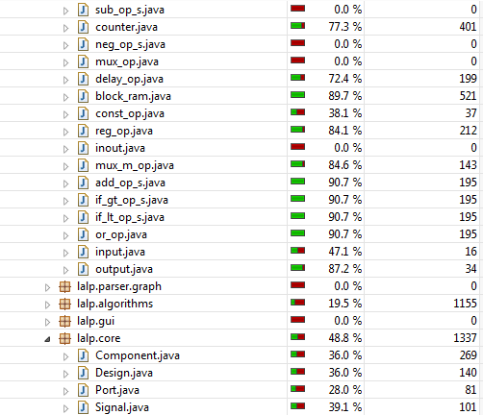
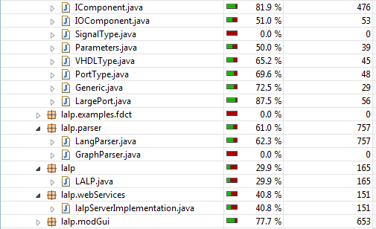Fig. 11.b Coverage analysis
- Simulation
  - Max
This example finds the greatest value in a matrix of integers. The matrix is defined as an array and is scanned one line at a time. The screenshot below shows the result of this example, 800 as the largest value. You can also see the input vector being scanned one integer at a time to be compared. This example took 20µs to execute.
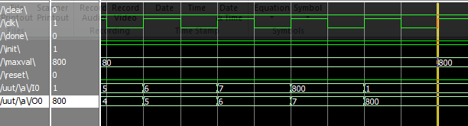
Fig. 12. Simulation of max

  - Fibonacci
This example shows a Fibonacci sequence from 0 to 32. It does the sequence in two parts. The first handles from 2^ 0 to 2^6. Then the second takes those values to calculate from 2^6 to2^ 32. The simulation below shows the result of each half Total execution time is 1µs.

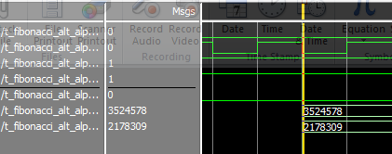
Fig. 13. Simulation of Fibonacci

  - ADPCM
The main aim in the ADPCM encoder/decoder is to take an analog signal and generate an almost identical digital signal from it. Because of the limitations of analog to digital hardware, we always have some data loss between steps. We can compensate by using adaptive differential pulse code modulation to fill in those gaps. This method predicts what values are expected based on the sample and is able to quantify the difference to an accurate value. The example below shows a sample where the area in red is the gap between steps and the value of 100 is the value calculated to be in used.

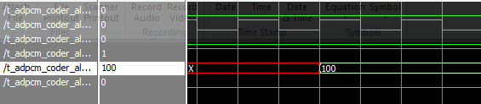
Fig. 14. Simulation of ADPCM

  - Bubble Sort
This is a sorting algorithm that runs through a list several times and compares each pair of neighboring numbers. If the numbers are in an incorrect order it will swap them. Below you can see the largest number sorted from the list is 32766, done in 38µs

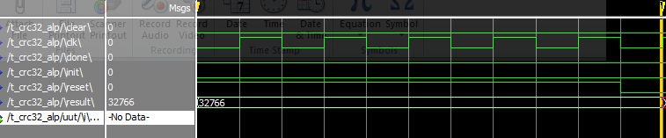
Fig. 15. Simulation of bubble sort

  - CRC
Cyclic Redundancy Check is used to detect redundancy errors in computer networks and storage devices. This example does “verification” by comparing values to a crc_table to compare values. This example verifies 10 memory values to the table. The result shows the last memory location verified. It runs in about 5µs for all 10 values.

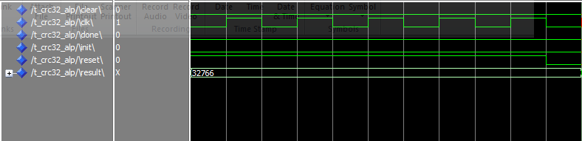
Fig. 16. Simulation of CRC

- Conclusion

The Language for Aggressive Loop Pipelining is basically designed to program the FPGAs including the abstraction levels i.e software or high level languages and the HDLs, more precisely C and VHDL. With the help of this language the programmers will now be able to achieve the aggressive loop pipelining which the traditional loop pipelining lacks, as they are software oriented approaches and are restricted to resource constraints which are compelled by micro processors and ASICs. Even by taking in a functional unit at a time for every operation i.e. even by loosening up the constraints, the optimum performance cannot be accurately achieved which is possible by the ALP schemes.
In this project we able to repeat the experiments (Inter-conversion, simulation and Graphviz) done by the founder [1] and augmented it our contribution (GUI, web services, conceptual UART and memory).
LALP is still riddled with limitations. Some of them are limited support for other FPGA boards, limited memory modules and no support for floating point operations. In CECS 531 we wish to work towards progressive realization of a worthy goal.
- Acknowledgements
We express our gratitude to the founder for assisting, aiding and guiding us through the entire process with arms wide open. We would also like to acknowledge our mentor Dr. Xiaolong Wu and our prestigious university.

REFERENCES
[1] R. Menotti, J. M. P. Cardoso, M. M. Fernandes and E. Marques, "On using LALP to map an audio encoder/decoder on FPGAs," in Industrial Electronics (ISIE), 2010 IEEE International Symposium on, 2010, pp. 3063-3068.
[2] R. Menotti, J. M. P. Cardoso, M. M. Fernandes and E. Marques, "LALP: A novel language to program custom FPGA-based architectures," in Computer Architecture and High Performance Computing, 2009. SBAC-PAD '09. 21st International Symposium on, 2009, pp. 3-10.
[3] R. Menotti, J. M. P. Cardoso, M. M. Fernandes and E. Marques, "Automatic generation of FPGA hardware accelerators using a domain specific language," in Field Programmable Logic and Applications, 2009. FPL 2009. International Conference on, 2009, pp. 457-461.

